WARREN CONSOLIDATED SCHOOLS PARENT RESOURCES

PARENT RESOURCES | ENGLISH | ARABIC
Parent Portal  (contact info, Schedule & grades) | Parent Portal | Parent Portal Set-up Arabic
Schoology K-5 (Computer “Classroom”) | Schoology Directions (K-5) | Schoology Directions (K-5)- Arabic
Schoology 6-12 (Computer “Classroom”) | Schoology Directions (6-12) | Schoology Directions (6-12)
Lunch App.com Directions | Lunch Application Instructions | Lunch Application Instructions- Arabic
Lunch App | Lunch App Link | Lunch App Link
Bus Stop Information | Determining Bus Stop Directions | Determining Bus Stop Directions- Arabic
Not sure if you contact information is up to date?
Call your child’s school to update or verify your Parent Contact Information in Parent Portal (phone number, home address, email address, emergency contacts)
Visit: www.wcskids.net for additional Parent Resources.

HELPFUL WCS PHONE NUMBERS

Registration: | 586-698-4478
Technology & Laptop IT Help Desk: | 586- 782-6999
Family Resource Assistants (Arabic help): | 586-698-4007  - Press 1: Cousino Path Schools  - Black, Carleton, Carter, Cousino, Cromie, Wilde, Wilkerson  - Press 2: SHHS Path Schools  - Carleton, Grissom, Holden, Jefferson, Sterling Heights HS, Susick, Willow Woods  - Press 3: Warren Mott Path Schools  - Beer, Harwood, Green Acres, Grissom, Lean, Siersma, Warren Mott

Do you need the website in another language?
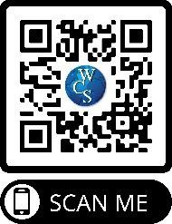
www.wcskids.net and our webpages can be translated into any language by selecting the Google Translate button on the bottom left corner of the main page.
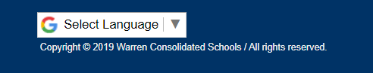
Please call your student’s school for any questions. We are here to help!

